

First Semester Examination, 2003

Question/Answer Booklet

YEAR 12 CHEMISTRY

Student Name: __________________________________

Time allowed for this paper
Reading time before commencing work: Ten minutes
Working time for paper: Three hours

Material required/recommended for this paper

To be provided by the supervisor
This Question/Answer Booklet
Separate Multiple Choice Answer Sheet
Chemistry Data Sheet (inside front cover of this Question/Answer Booklet)

To be provided by the candidate
Standard Items: Pens, pencils, eraser or correction fluid, ruler
Special Items: A 2B, B or HB pencil for the separate Multiple Choice Answer Sheet and calculators satisfying the conditions set by the Curriculum Council for this subject.

Important note to candidates
No other items may be taken into the examination room. It is your responsibility to ensure that you do not have any unauthorised notes or other items of a non-personal nature in the examination room. If you have any unauthorised material with you, hand it to the supervisor before reading any further.

Course Coordinator: Malcolm Cesareo
Structure of this paper

Part | Number of questions available | Number of questions to be attempted | Suggested working time | Marks available
1 Multiple choice | 30 | ALL | 55 | 60 (30%)
2 Short answers | 12 | ALL | 60 | 70 (35%)
3 Calculations | 6 | ALL | 45 | 50 (25%)
4 Extended answers | 2 | 1 | 20 | 20 (10%)
Total marks |  |  |  | 200 (100%)

Instructions to candidates

1. The rules for the conduct of Tertiary Entrance Examinations are detailed in the booklet TEE Handbook. Sitting this examination implies that you agree to abide by these rules.

2. Answer the questions according to the following instructions:
Part 1 Answer all questions, using a 2B, B or HB pencil, on the separate Multiple Choice Answer Sheet. Do not use a ball point or ink pen.

If you consider that two or more of the alternative responses are correct, choose the one you think is best. If you think you know an answer, mark it even if you are not certain you are correct. Marks will not be deducted for incorrect answers.

Feel free to write or do working on the question paper; many students who score high marks in the Multiple Choice Section do this.

Parts 2, 3 and 4 Write your answers in the spaces provided in this Question/Answer Booklet. A blue or black ball point or ink pen should be used.

Questions containing specific instructions to show working should be answered with a complete, logical, clear sequence of reasoning showing how the final answer was arrived at; correct answers which do not show working will not be awarded full marks.

3. The examiners recommend that you spend your reading time mainly reading the instructions to candidates and Parts 2, 3 and 4.

4. Chemical equations
For full marks, chemical equations should refer only to those species consumed in the reaction and the new species produced. These species may be ions [for example Ag⁺(aq)], molecules [for example NH₃(g), NH₃(aq), CH₃COOH(l), CH3COOH(aq)] or solids [for example BaSO₄(s), Cu(s), Na₂CO₃(s)].

PART 1 (60 marks)

Answer ALL questions in Part 1 on the Separate Multiple Choice Answer Sheet provided, use a 2B, B or HB pencil. Each question in this part is worth 2 marks.
_____________________________________________________________________

1. Calculate the mass of solute dissolved in 250 mL of 0.2 mol L⁻¹ sodium hydroxide solution.

a) 0.1 g b) 0.2g
c) 2.0 g d) 8.0g

2. 100 mL of 2.00 mol L⁻¹ sodium hydroxide is mixed with 50.0 mL of 2.50 mol L⁻¹ sodium hydroxide, then 50.0 mL of distilled water is added to the solution.
What is the concentration of the final sodium hydroxide solution produced?

a) 1.62 mol L⁻¹ b) 2.17 mol L⁻¹
c) 2.25 mol L⁻¹ d) 2.40 mol L⁻¹

3. Calculate the concentration of chloride ions in 20 mL of a 0.5 mol L⁻¹ solution of aluminium chloride.

a) 0.5 mol L⁻¹ b) 1.0 mol L⁻¹
c) 1.5 mol L⁻¹ d) 2.0 mol L⁻¹

4. Consider the following two solutions:

Solution 1 consists of 1 mol L⁻¹ iron (III) sulfate and Solution 2 consists of 1 mol L⁻¹ sodium sulfate.

Which of the following statements is TRUE?

a) The [SO₄²⁻] in Solution 1 is 1.5 times the [SO₄²⁻] in Solution 2.
b) The [Na⁺] is Solution 2 is equal to the [Fe³⁺] in Solution 1.
c) The [Na⁺] in Solution 2 is half the [SO₄²⁻] in Solution 1.
d) The [Fe³⁺] in Solution 1 is equal to the [SO₄²⁻] in Solution 2.

5. Identify which ONE of the following pairs of solutions would produce a precipitate when mixed together.

a) Fe(NO₃)₃ and K₃PO₄.
b) NH₄NO₃ and Na₂CO_{3.}
c) Ca(NO₃)₂ and NaCl.
d) MgCl₂ and NaBr.

6. What colour is Fe(OH)₂?

a) Green.
b) Brown.
c) White.
d) Yellow.

7. Which one of the equations below is NOT balanced?

a) 2KClO₃ 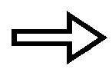 2KCl + 2O₂
b) Fe₂O₃(s) + 3CO(g) 2Fe(l) + 3CO₂(g)
c) Zn(s) + 2HCl(aq) ZnCl₂(aq) + H₂(g)
d) 2HgO 2Hg + O₂

The next two questions refer to the equation below which shows the decomposition of zinc carbonate upon heating.
_{heat}
ZnCO₃(s) ZnO(s) + CO₂(g)

8. If 2.5 g of zinc carbonate is heated, what mass of zinc oxide would be produced?

a) 0.02 g b) 0.8 g
c) 1.6 g d) 3.2 g

9. If the carbon dioxide produced in the above reaction was collected and conditions set to STP, what volume would the carbon dioxide gas occupy?

a) 88.0 mL b) 100.0 mL
c) 22.4 mL d) 448 mL

10. The equation for the reaction between hydrochloric acid and sodium thiosulfate can be represented as :

S₂O₃²⁻(aq) + 2H⁺(aq) H₂O(l) + SO₂(g) + S(s)

Which one of the following would NOT increase the rate of this reaction?

a) Increasing the temperature of the reacting solutions.
b) Increasing the concentration of sodium thiosulfate.
c) Increasing the concentration of the hydrochloric acid used.
d) Increasing the air pressure around the reaction vessel.

11. The equilibrium expression, k, for the reaction:

N₂O₄(g) 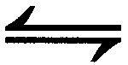 2NO₂(g), would be

a) k = [N₂O₄]
2[NO₂]
b) k = 2[NO₂]
[N₂O₄]
c) k = [N₂O₄]
[NO₂]²
d) k = [NO₂]²
[N₂O₄]

12. What would happen to the value of k in the reaction described in question 11, if the pressure of the N₂O₄ is doubled?

a) k would not be affected.
b) k would be halved.
c) k would be doubled.
d) k would increase by a factor of 4.

13. Which of the following is used as a primary standard in acid-base titrations?

a) Hydrochloric acid.
b) Sodium carbonate.
c) Sodium hydroxide.
d) Sulfuric acid.

14. Which one of the following acids is diprotic?

a) Nitric acid.
b) Phosphoric acid.
c) Ethanoic acid.
d) Sulfuric acid.

15. If a solution has a pH of 10, then the hydroxide ion concentration of the solution is

a) 10 mol L⁻¹
b) 0.1 mol L⁻¹
c) 0.04 mol L⁻¹
d) 0.0001 mol L⁻¹

16. In volumetric analysis work, the following items of glassware are used:

I. Pipette
II. Volumetric flask
III. Conical flask
IV. Burette

Which of these items must be rinsed with a sample of the solution they will contain prior to them being filled with this solution for a titration?

a) All of them
b) I and IV.
c) I, II and IV.
d) III only.

17. The diagram below shows the level of hydrochloric acid in the burette immediately before and after a titration.

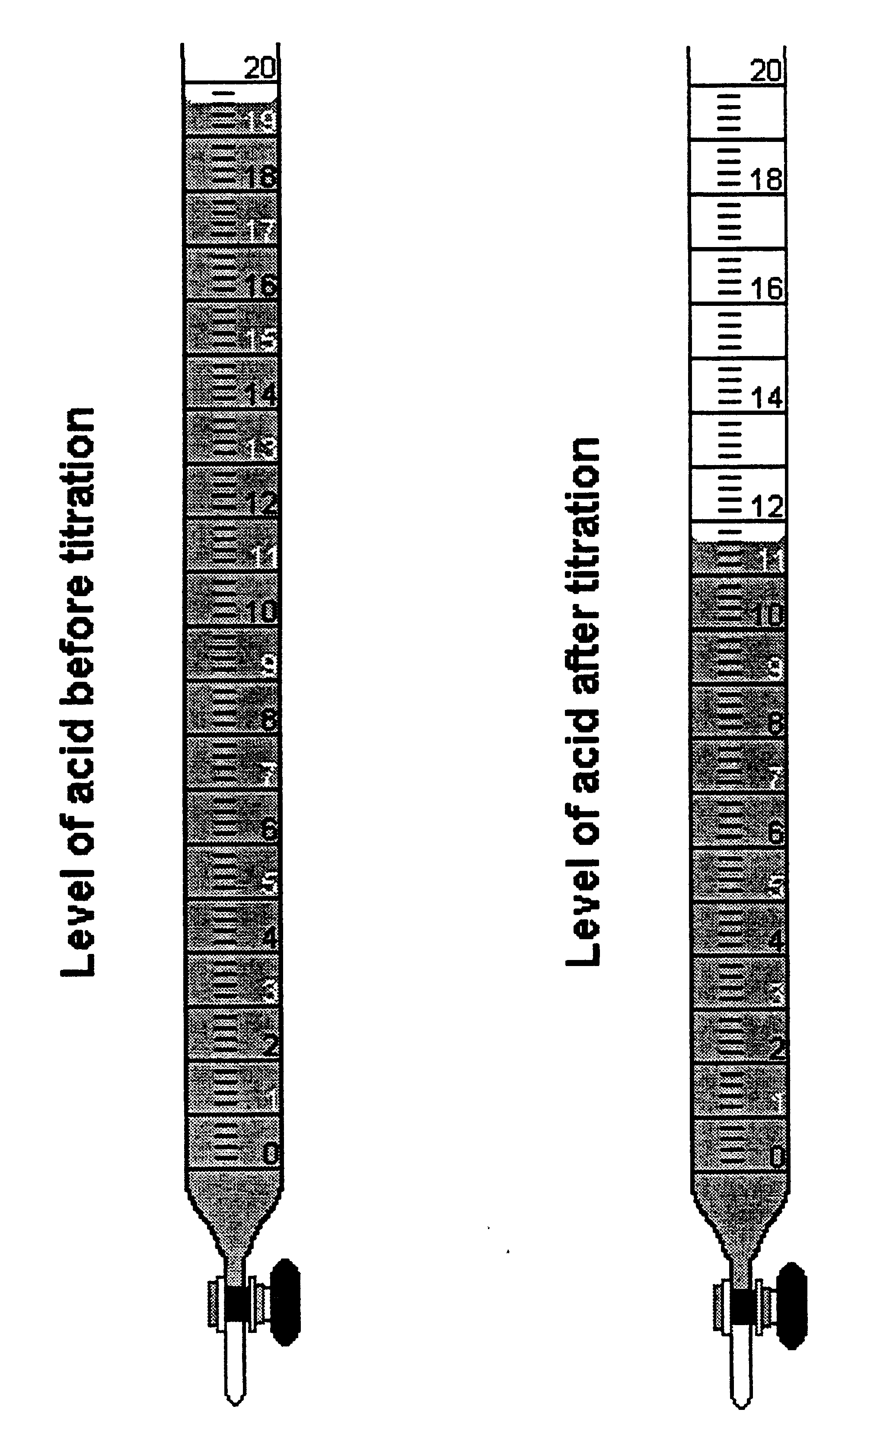

What volume of acid has been used in this titration?

a) 7.0 mL
b) 8.0 mL
c) 8.2 mL
d) 11.6 mL

18. What instrument should be used to accurately measure and deliver exactly 20 mL of the primary standard?

a) A graduated cylinder.
b) An eyedropper.
c) A burette.
d) A pipette.

19. Which one of the following is a reason why potassium permanganate is unsuitable as a primary standard?

a) The exact molecular formula is unknown.
b) Potassium permanganate is an oxidising agent.
c) Solutions of potassium permanganate are unstable and decompose when exposed to light.
d) Its molar mass is too high.

20. Study the following equation for the reaction between concentrated nitric acid and copper metal and then answer the question below.

Cu(s) + 4H⁺(aq) + 2NO₃⁻(aq) Cu²⁺(aq) + 2H₂O(l) + 2NO₂(g)

The reducing agent is

a) copper metal.
b) nitric acid.
c) hydrogen ions.
d) nitrogen doxide.

21. Which one of the following is a strong oxidising agent, used both as a bleaching agent and in the purification of water?

a) Hydrogen peroxide, H₂O₂.
b) Hypochlorite ion, OCl⁻.
c) Hydrogen chloride, HCl.
d) Sulfuric acid, H₂SO₄.

22. What would you expect to observe when chlorine is added to a solution of sodium bromide.

a) The solution would turn red.
b) A purple precipitate would be formed.
c) There would be no reaction.
d) The solution would become green.

23. What is the oxidation number of manganese in the permanganate ion, MnO₄⁻?

a) –1 b) +7
c) -7 d) +8

24. Oxidation occurs when

a) a substance donates hydrogen ions.
b) a substance becomes negatively charged.
c) a substance gives up electrons.
d) a substance gains electrons.

25. Which of the following oxides is acidic?

a) Na₂O
b) MgO
c) Al₂O₃
d) SO₂

26. What is the function of the limestone in the extraction process?

a) It acts as a catalyst in the reaction.
b) Its decomposition at high temperatures provides the calcium oxide and carbon dioxide needed for the extraction process.
c) It forms a layer of slag over the iron to prevent its oxidation.
d) It acts as an insulator of heat.

27. Which one of the following is NOT a weak electrolyte?

a) Acetic acid.
b) Water.
c) Ethanol
d) Ammonia

28. The equation below shows the reaction of ammonia with water:

NH₃(aq) + H₂O(l) NH₄⁺(aq) + OH⁻(aq)

According to the Bronsted-Lowry theory of acids and bases, the water molecules in the above reaction

a) act as an acid by giving up a proton.
b) act as a base by accepting a proton.
c) act as an acid by neutralising the ammonia.
d) act as an acid by giving up electrons.

29. For the reaction, HF(aq) + H₂O(l) H₃O⁺(aq) + F⁻(aq)
the conjugate base of HF is

a) H₂O
b) H₃O⁺
c) F⁻
d) OH⁻

30. Which of the following best defines a strong acid?

a) A strong acid has a high concentration of hydrogen ions.
b) A strong acid is one which fully ionises in aqueous solution.
c) A strong acid has a pH of less than 2.
d) A strong acid is one which turns blue litmus red.

END OF PART 1
PART 2 (70 marks)
Answer ALL questions in Part 2 in the spaces provided below.

1. Write equations for any reactions that occur in the following procedures. If no reaction occurs write 'no reaction'.

In each case describe in full what you would observe, including any
- colours
- odours
- precipitates (give the colour)
- gases evolved (give the colour or describe as colourless).

If no change is observed, you should must state this as the observation.

(a) Dilute sulfuric acid is added to potassium chromate.

Equation ________________________________________________________________

Observation ______________________________________________________________

________________________________________________________________________
[3 marks]

(b) Dilute hydrochloric acid is added to Co(H₂O)₆²⁺(aq).

Equation ________________________________________________________________

Observation ______________________________________________________________

________________________________________________________________________
[3 marks]

(c) Acidified potassium dichromate solution is added to a solution of oxalic acid.

Equation ________________________________________________________________

Observation ______________________________________________________________

________________________________________________________________________
[3 marks]

(d) Copper metal is added to concentrated nitric acid.

Equation ________________________________________________________________

Observation ______________________________________________________________

________________________________________________________________________
[3 marks]
2. An excess of CaCO₃ in the form of large pieces of marble is reacted with 500 mL hydrochloric acid in an open flask standing on a balance. The loss in mass of the contents of the flask is shown graphically below.

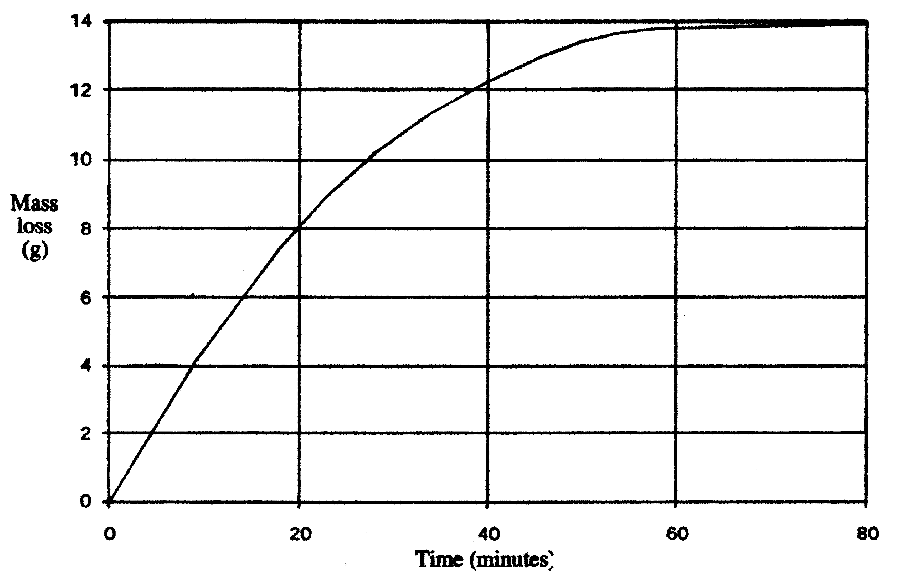
(a) Write the equation for the reaction which occur. Why is there a loss in mass of the flask and its contents?

________________________________________________________________________

________________________________________________________________________

________________________________________________________________________

________________________________________________________________________

________________________________________________________________________
[2 marks]

(b) Calculate the average rate of reaction between 0-20 minutes and also between 20-40 minutes (Take care with units). Explain any difference between these two rates of reaction.

________________________________________________________________________

________________________________________________________________________

________________________________________________________________________

________________________________________________________________________

________________________________________________________________________
[2 marks]

(c) Why does the mass loss of the flask not increase after 70 minutes?

________________________________________________________________________

________________________________________________________________________

________________________________________________________________________

________________________________________________________________________

________________________________________________________________________
[l mark]

(d) Explain clearly what would have been the effect on the initial rate of reaction if small chips of marble had been used?

________________________________________________________________________

________________________________________________________________________

________________________________________________________________________

________________________________________________________________________
[l mark]

3. Many reactions require a catalyst.

(a) Identify two different industrial reactions that require a catalyst. Specify the catalyst used in each type of reaction.

________________________________________________________________________

________________________________________________________________________

________________________________________________________________________

________________________________________________________________________

________________________________________________________________________
[2 marks]

(b) Explain the purpose of a catalyst in a chemical reaction. Use a diagram in your answer.

________________________________________________________________________

________________________________________________________________________

________________________________________________________________________

________________________________________________________________________
[3 marks]

4. Identify by name or formula an example of each of the following

Description | Name or Formula
A positively charged complex ion
A halogen which is liquid at room temperature and pressure

A salt that dissolves in water to give an acidic solution

A weak acid other than acetic acid

A substance that can be used as a primary standard for redox titrations

A diprotic acid

A secondary standard used in many acid-base titrations

[7 marks]

5. Consider the following reaction:

3Cl₂(g) + 6NaOH(aq) -------> 5NaCl(aq) + NaClO₃(aq) + 3H₂O(l)

What is the oxidation state of

(a) Cl in Cl₂(g) ___________________________________________________________
[1 mark]

(b) Cl in NaCl(aq) ________________________________________________________
[1 mark]

(c) Cl in NaClO₃(aq) ______________________________________________________
[1 mark]

(d) Explain why the above reaction is classified as a disproportionation reaction.

________________________________________________________________________

________________________________________________________________________

________________________________________________________________________

________________________________________________________________________
[1 mark]

6. Complete and balance the following equation

(a) As₂O₃(s) + NO₃⁻(aq) ------> H₃AsO₄(aq) + N₂O₃(aq) (basic solution)

________________________________________________________________________

________________________________________________________________________

________________________________________________________________________

________________________________________________________________________

________________________________________________________________________

________________________________________________________________________

________________________________________________________________________

________________________________________________________________________

________________________________________________________________________

________________________________________________________________________
[7 marks]

(b) For the above reaction what is the oxidant? __________________________________
[1 mark]
(c) For the previous reaction what is the oxidising agent? __________________________
[1 mark]

(d) What is the oxidation state of As in H₃AsO₄? ________________________________
[1 mark]

7. Use the information given below to identify the elements X and Y. Justify your choices.

The oxides have formula of XO and YO₂.
XO is a solid which dissolves in water producing a basic solution.
YO₂ is a colourless, odourless gas which dissolves in water producing an acidic solution.
The element X is the third member of its group in the periodic table.

________________________________________________________________________

________________________________________________________________________

________________________________________________________________________

________________________________________________________________________

________________________________________________________________________

________________________________________________________________________

________________________________________________________________________

________________________________________________________________________

________________________________________________________________________

________________________________________________________________________
[3 marks]

8. Consider the equilibrium reaction between hydrogen chloride gas and oxygen gas using a suitable catalyst:

4HCl(g) + O₂(g) 2H₂O(g) + 2Cl₂(g) ΔΗ = -280 kJ mol⁻¹

Complete the table below by:

(a) indicating the change in the amount of hydrogen chloride gas (write either “more”, “less” or “unchanged”) after each of the following changes to conditions at equilibrium have been made.

(b) giving also a brief reason for your choice based on accepted chemical principles.

Change imposed on the system | Effect on amount of HCl(g) present
1. The temperature of the  system is raised. | (a)………………………………………..………………….  (b) Reason…………………………………………………..  ………………………………………………………………  ………………………………………………………..……
2. The pressure of the  system is doubled by  halving the volume of the  reaction vessel. | (a)…………………………………………………………..  (b) Reason…………………………………..………………  ………………………………………………..….…………  ……………………………………………………..………
3. The surface area of the  catalyst is increased | (a)…………………………………………………….……..  (b) Reason………………………………………..…………  ………………………………………………………………  ………………………………………………………………
[9 marks]

9. Consider the following diagram for a chemical system containing three substances represented by A, B and C:

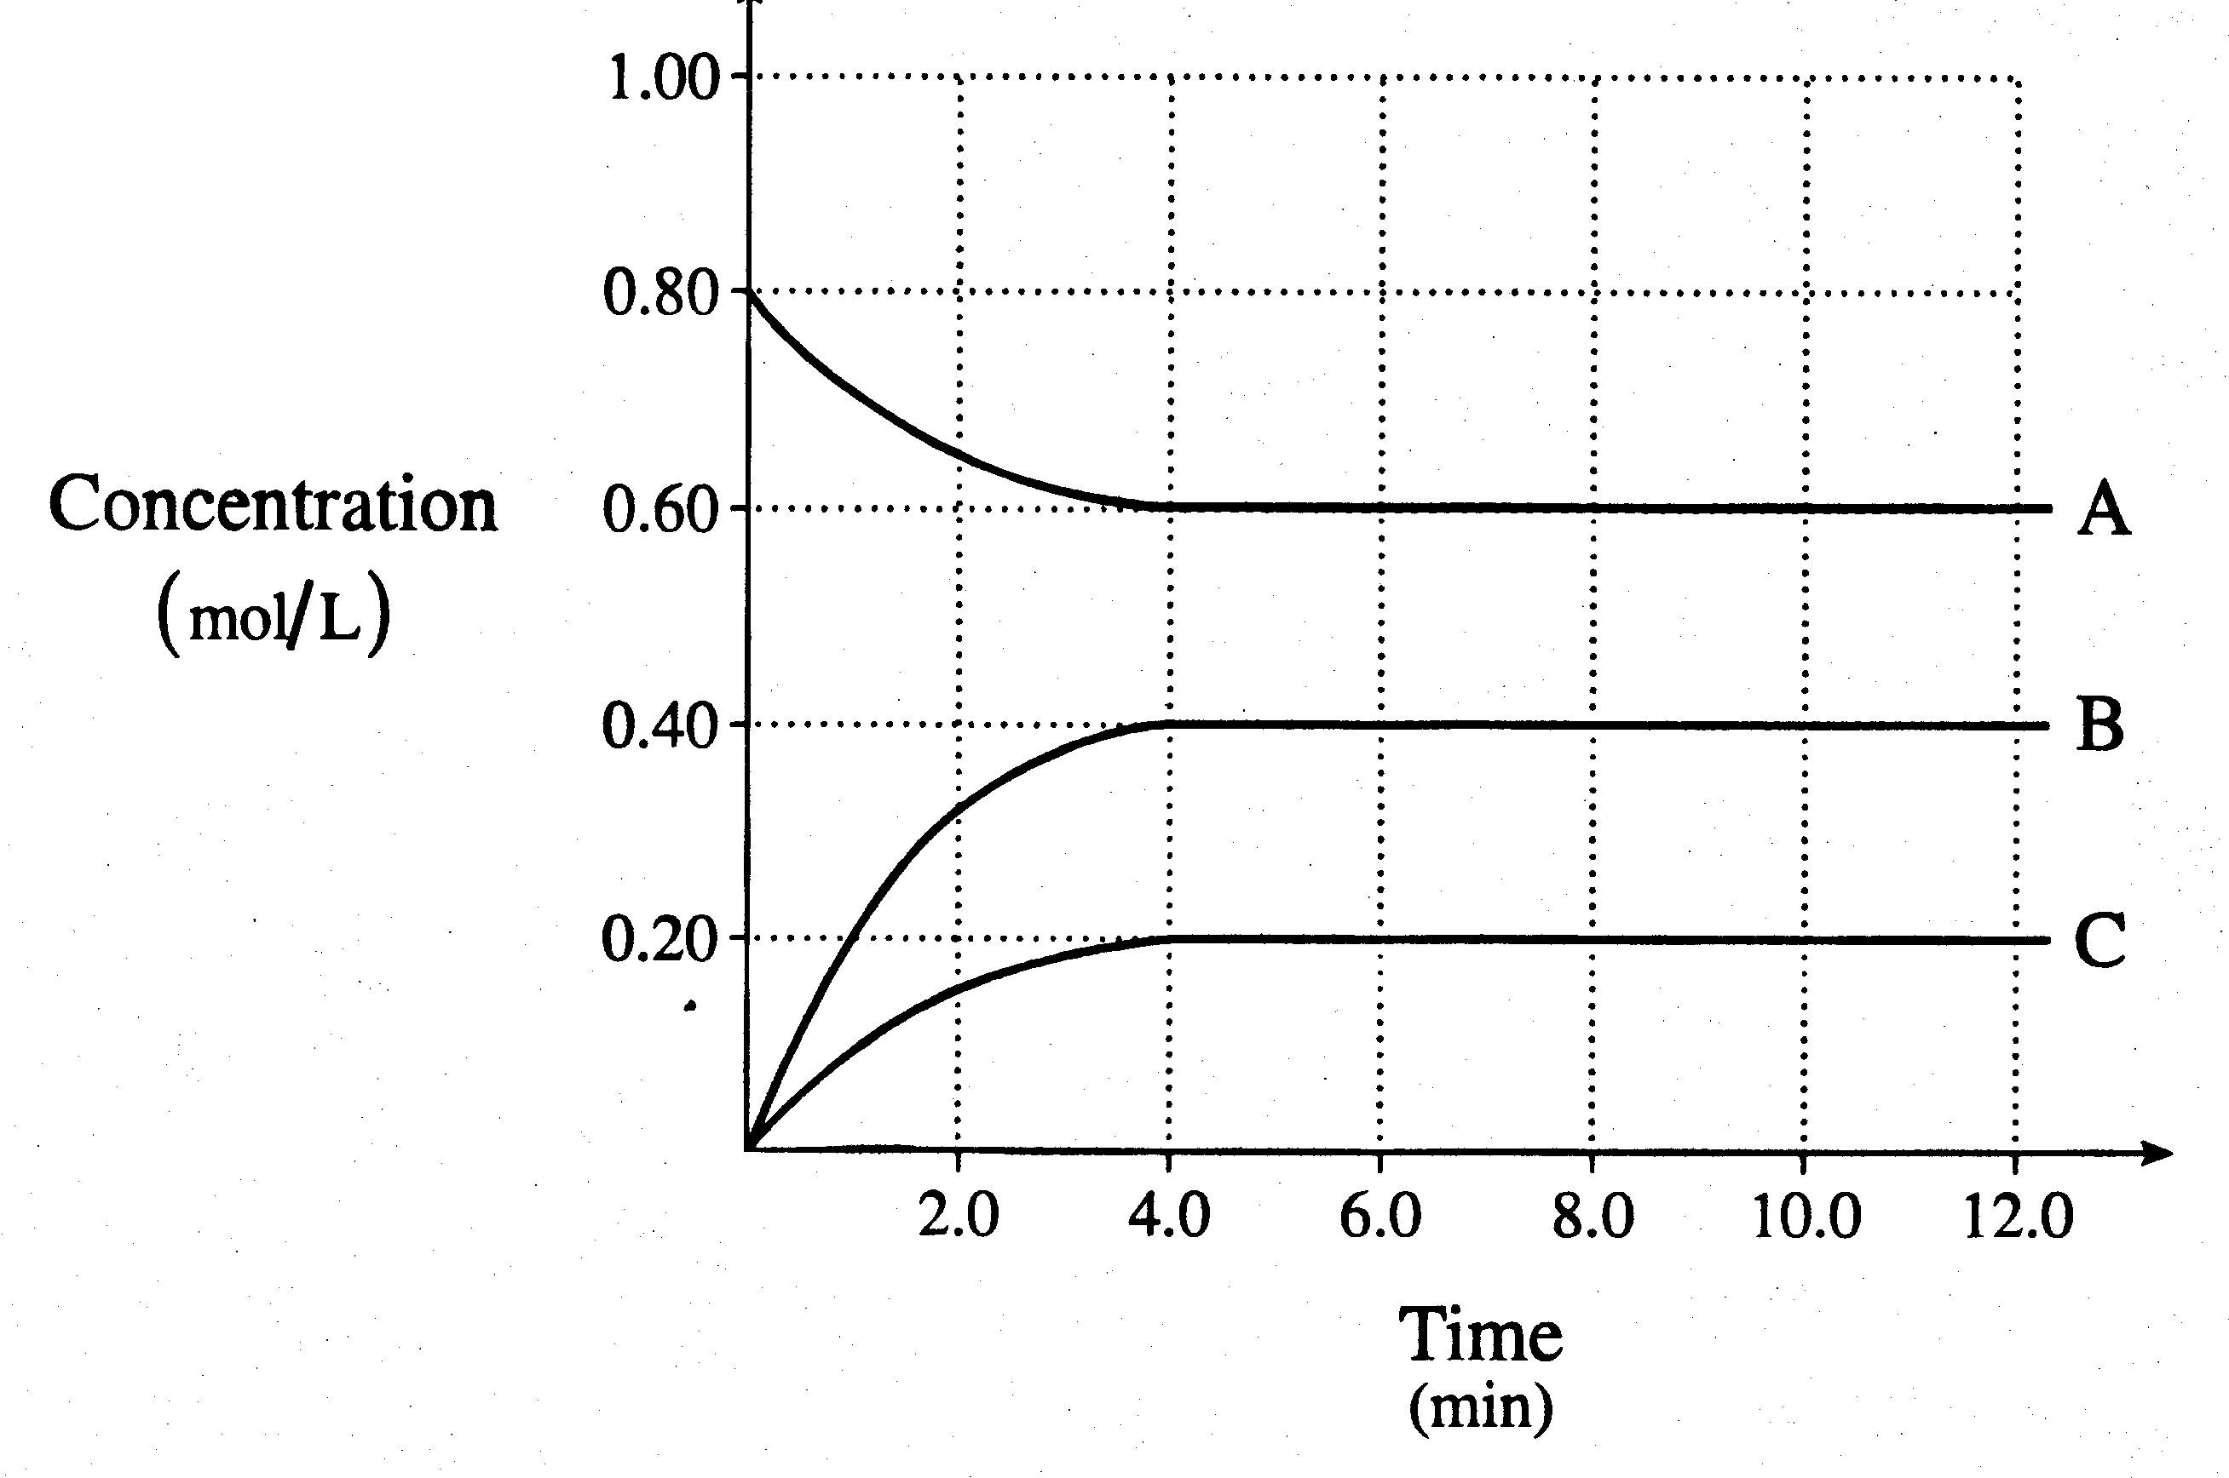

(a) What feature of the graph indicates that the system reaches equilibrium? Explain

________________________________________________________________________

________________________________________________________________________

________________________________________________________________________

________________________________________________________________________

________________________________________________________________________
[2 marks]

(b) Write a balanced equation for the equilibrium reaction.

________________________________________________________________________

________________________________________________________________________

________________________________________________________________________

________________________________________________________________________
[2 marks]

(c) Calculate K for this reaction.

________________________________________________________________________

________________________________________________________________________

________________________________________________________________________

________________________________________________________________________

________________________________________________________________________
[2 marks]

10. Consider the equilibrium:

BaSO₄(s) + H₂O(l) Ba²⁺(aq) + SO₄²⁻(aq)

(a) Why is this described as dynamic equilibrium?

________________________________________________________________________

________________________________________________________________________

________________________________________________________________________

________________________________________________________________________

________________________________________________________________________
[2 marks]

(b) Given a small amount of BaSO₄ containing radioactive barium, explain how this could be used in an experiment to show that the equilibrium above is dynamic.

________________________________________________________________________

________________________________________________________________________

________________________________________________________________________

________________________________________________________________________

________________________________________________________________________

________________________________________________________________________

________________________________________________________________________

________________________________________________________________________
[2 marks]

11. What is the function of carbon in the CIP process?

________________________________________________________________________

________________________________________________________________________

________________________________________________________________________

________________________________________________________________________

________________________________________________________________________
[1 mark]

12. Hydrazine, N₂H₄, is sometimes used as a rocket fuel. If F₂(g) is used as an oxidising agent, its heat of combustion is:

N₂H₄ + 2F₂(g) ------> N₂(g) + 4HF(g) ΔH = -1126kJmol⁻¹

Draw a potential energy diagram for the above reaction showing all information on the diagram.

[3 marks]
END OF PART 2
PART 3 (50 marks)

Answer ALL questions in Part 3. The calculations are to be set out in detail in this Question/Answer Booklet. Marks will be allocated for correct equations and clear setting out, even if you cannot complete the problem. When questions are divided into sections, clearly distinguish each section using (a), (b), and so on. Express your final numerical answers to three (3) significant figures where appropriate, and provide units where applicable. Information which may be necessary for solving the problems is located on the separate Chemistry Data Sheet. Show clear reasoning: if you don’t, you will lose marks.
____________________________________________________________________________
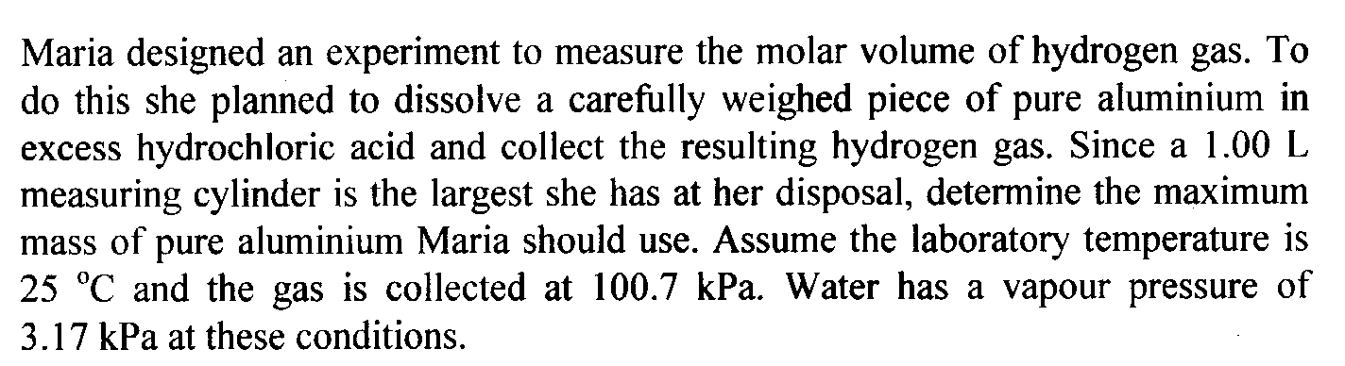
1.

[6 marks]

____________________________________________________________________________

____________________________________________________________________________

____________________________________________________________________________

____________________________________________________________________________

____________________________________________________________________________

____________________________________________________________________________

____________________________________________________________________________

____________________________________________________________________________

____________________________________________________________________________

____________________________________________________________________________

____________________________________________________________________________

____________________________________________________________________________

____________________________________________________________________________

____________________________________________________________________________

____________________________________________________________________________

____________________________________________________________________________

____________________________________________________________________________

____________________________________________________________________________

____________________________________________________________________________

____________________________________________________________________________

____________________________________________________________________________

____________________________________________________________________________

____________________________________________________________________________

____________________________________________________________________________

____________________________________________________________________________

____________________________________________________________________________

____________________________________________________________________________

____________________________________________________________________________

____________________________________________________________________________

____________________________________________________________________________

____________________________________________________________________________

____________________________________________________________________________

____________________________________________________________________________

____________________________________________________________________________

____________________________________________________________________________

____________________________________________________________________________

____________________________________________________________________________

____________________________________________________________________________

____________________________________________________________________________

____________________________________________________________________________
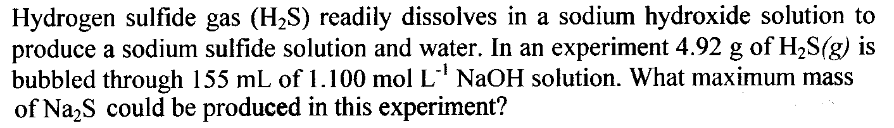
2.

[8 marks]

____________________________________________________________________________

____________________________________________________________________________

____________________________________________________________________________

____________________________________________________________________________

____________________________________________________________________________

____________________________________________________________________________

____________________________________________________________________________

____________________________________________________________________________

____________________________________________________________________________

____________________________________________________________________________

____________________________________________________________________________

____________________________________________________________________________

____________________________________________________________________________

____________________________________________________________________________

____________________________________________________________________________

____________________________________________________________________________

____________________________________________________________________________

____________________________________________________________________________

____________________________________________________________________________

____________________________________________________________________________

____________________________________________________________________________

____________________________________________________________________________

____________________________________________________________________________

____________________________________________________________________________

____________________________________________________________________________

____________________________________________________________________________

____________________________________________________________________________

____________________________________________________________________________

____________________________________________________________________________

____________________________________________________________________________

____________________________________________________________________________

____________________________________________________________________________

____________________________________________________________________________

____________________________________________________________________________

____________________________________________________________________________

____________________________________________________________________________

____________________________________________________________________________

____________________________________________________________________________

____________________________________________________________________________

____________________________________________________________________________

____________________________________________________________________________

____________________________________________________________________________

____________________________________________________________________________

____________________________________________________________________________

____________________________________________________________________________

____________________________________________________________________________

____________________________________________________________________________

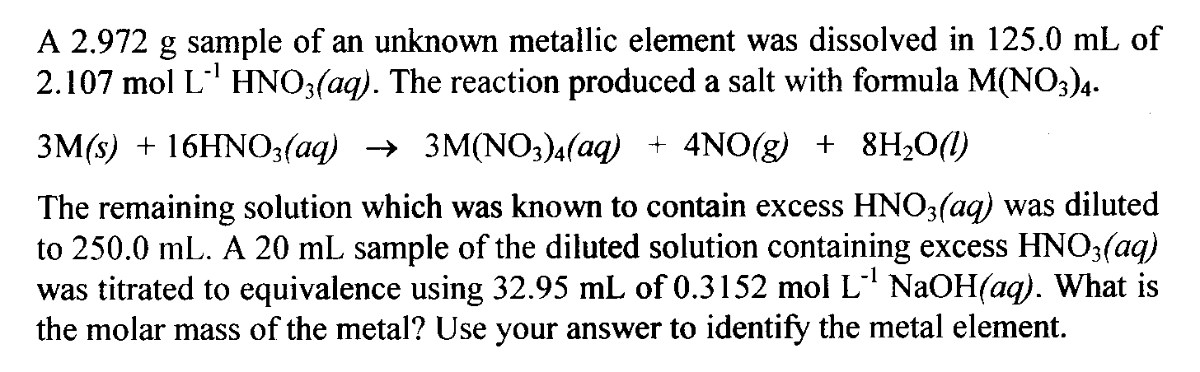
3.

[9 marks]

____________________________________________________________________________

____________________________________________________________________________

____________________________________________________________________________

____________________________________________________________________________

____________________________________________________________________________

____________________________________________________________________________

____________________________________________________________________________

____________________________________________________________________________

____________________________________________________________________________

____________________________________________________________________________

____________________________________________________________________________

____________________________________________________________________________

____________________________________________________________________________

____________________________________________________________________________

____________________________________________________________________________

____________________________________________________________________________

____________________________________________________________________________

____________________________________________________________________________

____________________________________________________________________________

____________________________________________________________________________

____________________________________________________________________________

____________________________________________________________________________

____________________________________________________________________________

____________________________________________________________________________

____________________________________________________________________________

____________________________________________________________________________

____________________________________________________________________________

____________________________________________________________________________

____________________________________________________________________________

____________________________________________________________________________

____________________________________________________________________________

____________________________________________________________________________

____________________________________________________________________________

____________________________________________________________________________

____________________________________________________________________________

____________________________________________________________________________

____________________________________________________________________________

____________________________________________________________________________

____________________________________________________________________________

____________________________________________________________________________

____________________________________________________________________________

____________________________________________________________________________

____________________________________________________________________________

____________________________________________________________________________

____________________________________________________________________________
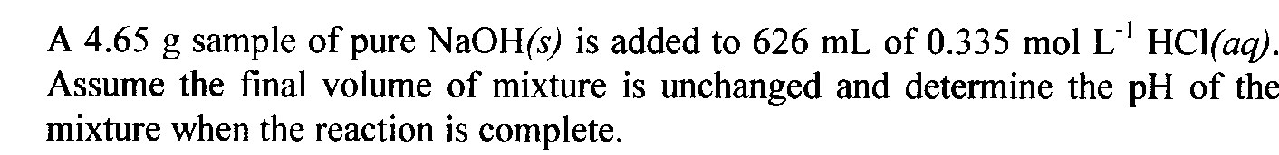
4.

[8 marks]

____________________________________________________________________________

____________________________________________________________________________

____________________________________________________________________________

____________________________________________________________________________

____________________________________________________________________________

____________________________________________________________________________

____________________________________________________________________________

____________________________________________________________________________

____________________________________________________________________________

____________________________________________________________________________

____________________________________________________________________________

____________________________________________________________________________

____________________________________________________________________________

____________________________________________________________________________

____________________________________________________________________________

____________________________________________________________________________

____________________________________________________________________________

____________________________________________________________________________

____________________________________________________________________________

____________________________________________________________________________

____________________________________________________________________________

____________________________________________________________________________

____________________________________________________________________________

____________________________________________________________________________

____________________________________________________________________________

____________________________________________________________________________

____________________________________________________________________________

____________________________________________________________________________

____________________________________________________________________________

____________________________________________________________________________

____________________________________________________________________________

____________________________________________________________________________

____________________________________________________________________________

____________________________________________________________________________

____________________________________________________________________________

____________________________________________________________________________

____________________________________________________________________________

____________________________________________________________________________

____________________________________________________________________________

____________________________________________________________________________

____________________________________________________________________________

____________________________________________________________________________

____________________________________________________________________________

____________________________________________________________________________

____________________________________________________________________________

____________________________________________________________________________

____________________________________________________________________________

____________________________________________________________________________

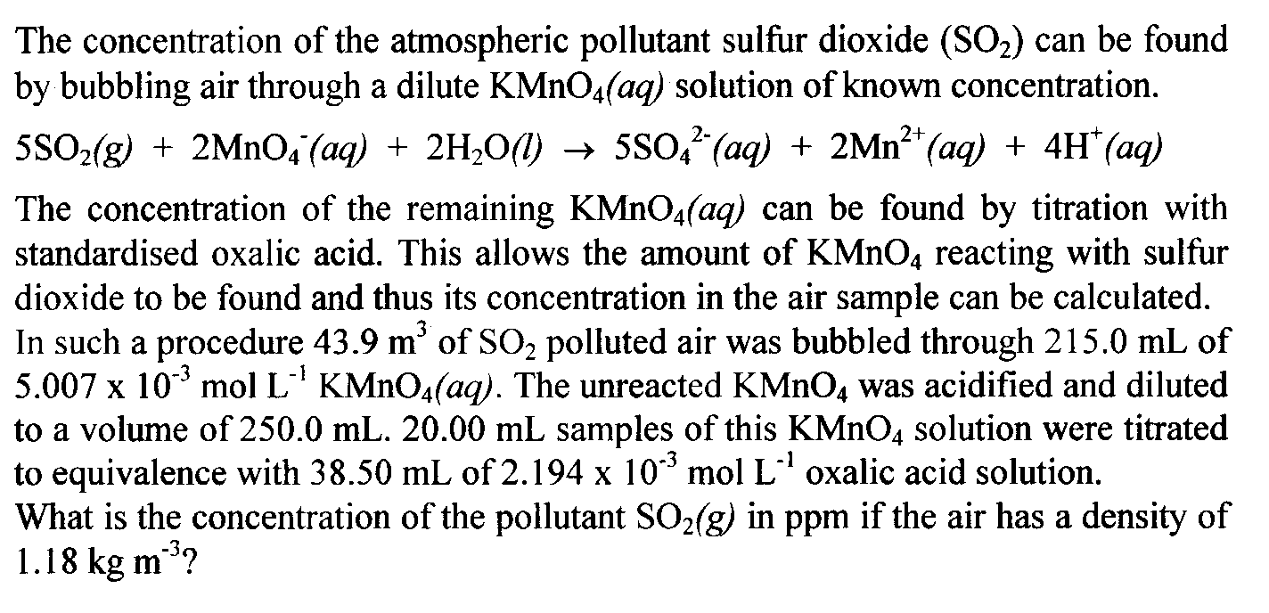
5.

[12 marks]

____________________________________________________________________________

____________________________________________________________________________

____________________________________________________________________________

____________________________________________________________________________

____________________________________________________________________________

____________________________________________________________________________

____________________________________________________________________________

____________________________________________________________________________

____________________________________________________________________________

____________________________________________________________________________

____________________________________________________________________________

____________________________________________________________________________

____________________________________________________________________________

____________________________________________________________________________

____________________________________________________________________________

____________________________________________________________________________

____________________________________________________________________________

____________________________________________________________________________

____________________________________________________________________________

____________________________________________________________________________

____________________________________________________________________________

____________________________________________________________________________

____________________________________________________________________________

____________________________________________________________________________

____________________________________________________________________________

____________________________________________________________________________

____________________________________________________________________________

____________________________________________________________________________

____________________________________________________________________________

____________________________________________________________________________

____________________________________________________________________________

____________________________________________________________________________

____________________________________________________________________________

____________________________________________________________________________

____________________________________________________________________________

____________________________________________________________________________

____________________________________________________________________________

____________________________________________________________________________

____________________________________________________________________________

____________________________________________________________________________

____________________________________________________________________________

____________________________________________________________________________

____________________________________________________________________________
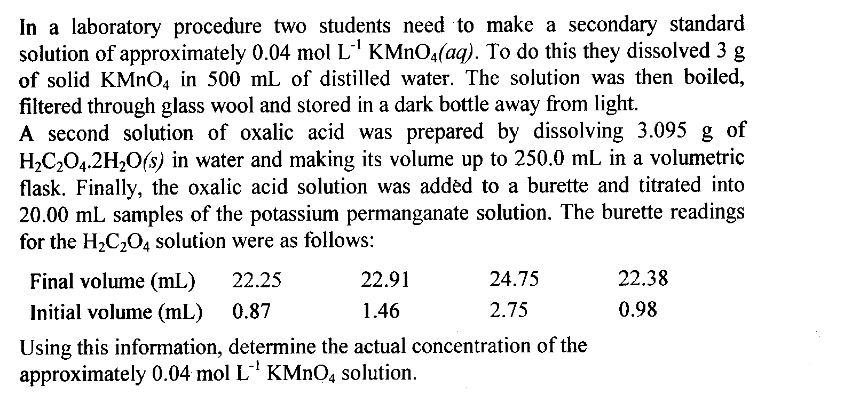

6.

[7 marks]

____________________________________________________________________________

____________________________________________________________________________

____________________________________________________________________________

____________________________________________________________________________

____________________________________________________________________________

____________________________________________________________________________

____________________________________________________________________________

____________________________________________________________________________

____________________________________________________________________________

____________________________________________________________________________

____________________________________________________________________________

____________________________________________________________________________

____________________________________________________________________________

____________________________________________________________________________

____________________________________________________________________________

____________________________________________________________________________

____________________________________________________________________________

____________________________________________________________________________

____________________________________________________________________________

____________________________________________________________________________

____________________________________________________________________________

____________________________________________________________________________

____________________________________________________________________________

____________________________________________________________________________

____________________________________________________________________________

____________________________________________________________________________

____________________________________________________________________________

____________________________________________________________________________

____________________________________________________________________________

____________________________________________________________________________

____________________________________________________________________________

____________________________________________________________________________

____________________________________________________________________________

____________________________________________________________________________

____________________________________________________________________________

____________________________________________________________________________

____________________________________________________________________________

____________________________________________________________________________

____________________________________________________________________________

____________________________________________________________________________

____________________________________________________________________________

____________________________________________________________________________
PART 4 (20 marks)

Answer ONE of the following extended answer questions. Where applicable use equations, diagrams and illustrative examples of the chemistry you are describing.

Marks are awarded for the relevant chemical content of your answer, but also for coherence and clarity of expression. Your answer should be presented in about 1.5 - 2 pages. Begin your essay on the lined page following the end of the questions.
_____________________________________________________________________

1. You are to present a series of laboratory sessions on acid-base volumetric analysis. Discuss what you would present and why keeping in mind the importance of good laboratory technique, the correct use of various pieces of equipment and the need for primary and secondary standards.

OR

2. Compare and contrast the reactions involved in the chemical purification and extraction reactions for gold and iron. In what way are the differences in the properties of these two metals evident in the use of the metals in everyday life?

END OF QUESTIONS
Check that you have written your Name on the front cover of this booklet
Write your response to Part 4 below.

____________________________________________________________________________

____________________________________________________________________________

____________________________________________________________________________

____________________________________________________________________________

____________________________________________________________________________

____________________________________________________________________________

____________________________________________________________________________

____________________________________________________________________________

____________________________________________________________________________

____________________________________________________________________________

____________________________________________________________________________

____________________________________________________________________________

____________________________________________________________________________

____________________________________________________________________________

____________________________________________________________________________

____________________________________________________________________________

____________________________________________________________________________

____________________________________________________________________________

____________________________________________________________________________

____________________________________________________________________________

____________________________________________________________________________

____________________________________________________________________________

____________________________________________________________________________

____________________________________________________________________________

____________________________________________________________________________

____________________________________________________________________________

____________________________________________________________________________

____________________________________________________________________________

____________________________________________________________________________

____________________________________________________________________________

____________________________________________________________________________

____________________________________________________________________________

____________________________________________________________________________

____________________________________________________________________________

____________________________________________________________________________

____________________________________________________________________________

____________________________________________________________________________

____________________________________________________________________________

____________________________________________________________________________

____________________________________________________________________________

____________________________________________________________________________

____________________________________________________________________________

____________________________________________________________________________

____________________________________________________________________________

____________________________________________________________________________

____________________________________________________________________________

____________________________________________________________________________

____________________________________________________________________________

____________________________________________________________________________

____________________________________________________________________________

____________________________________________________________________________

____________________________________________________________________________

____________________________________________________________________________

____________________________________________________________________________

____________________________________________________________________________

____________________________________________________________________________

____________________________________________________________________________

____________________________________________________________________________

____________________________________________________________________________

____________________________________________________________________________

____________________________________________________________________________

____________________________________________________________________________

____________________________________________________________________________

____________________________________________________________________________

____________________________________________________________________________

____________________________________________________________________________

____________________________________________________________________________

____________________________________________________________________________

____________________________________________________________________________

____________________________________________________________________________

____________________________________________________________________________

____________________________________________________________________________

____________________________________________________________________________

____________________________________________________________________________

____________________________________________________________________________

____________________________________________________________________________

____________________________________________________________________________

____________________________________________________________________________

____________________________________________________________________________

____________________________________________________________________________

____________________________________________________________________________

____________________________________________________________________________

____________________________________________________________________________

____________________________________________________________________________

____________________________________________________________________________

____________________________________________________________________________

____________________________________________________________________________

____________________________________________________________________________

____________________________________________________________________________

____________________________________________________________________________

____________________________________________________________________________

____________________________________________________________________________

____________________________________________________________________________

____________________________________________________________________________

____________________________________________________________________________

____________________________________________________________________________

____________________________________________________________________________

____________________________________________________________________________

____________________________________________________________________________

____________________________________________________________________________

____________________________________________________________________________

____________________________________________________________________________

____________________________________________________________________________

____________________________________________________________________________

____________________________________________________________________________

____________________________________________________________________________

____________________________________________________________________________

____________________________________________________________________________

____________________________________________________________________________

____________________________________________________________________________

____________________________________________________________________________

____________________________________________________________________________

____________________________________________________________________________

____________________________________________________________________________

____________________________________________________________________________

____________________________________________________________________________

____________________________________________________________________________

____________________________________________________________________________

____________________________________________________________________________

____________________________________________________________________________

____________________________________________________________________________

____________________________________________________________________________

____________________________________________________________________________

____________________________________________________________________________

____________________________________________________________________________

____________________________________________________________________________

____________________________________________________________________________

____________________________________________________________________________

____________________________________________________________________________

____________________________________________________________________________

____________________________________________________________________________

____________________________________________________________________________

____________________________________________________________________________

____________________________________________________________________________

____________________________________________________________________________

____________________________________________________________________________

____________________________________________________________________________

____________________________________________________________________________

____________________________________________________________________________

____________________________________________________________________________

____________________________________________________________________________

____________________________________________________________________________

____________________________________________________________________________

____________________________________________________________________________

____________________________________________________________________________

____________________________________________________________________________

____________________________________________________________________________

____________________________________________________________________________

____________________________________________________________________________

